Personal Portfolio

Release 2

**Leave Requests** 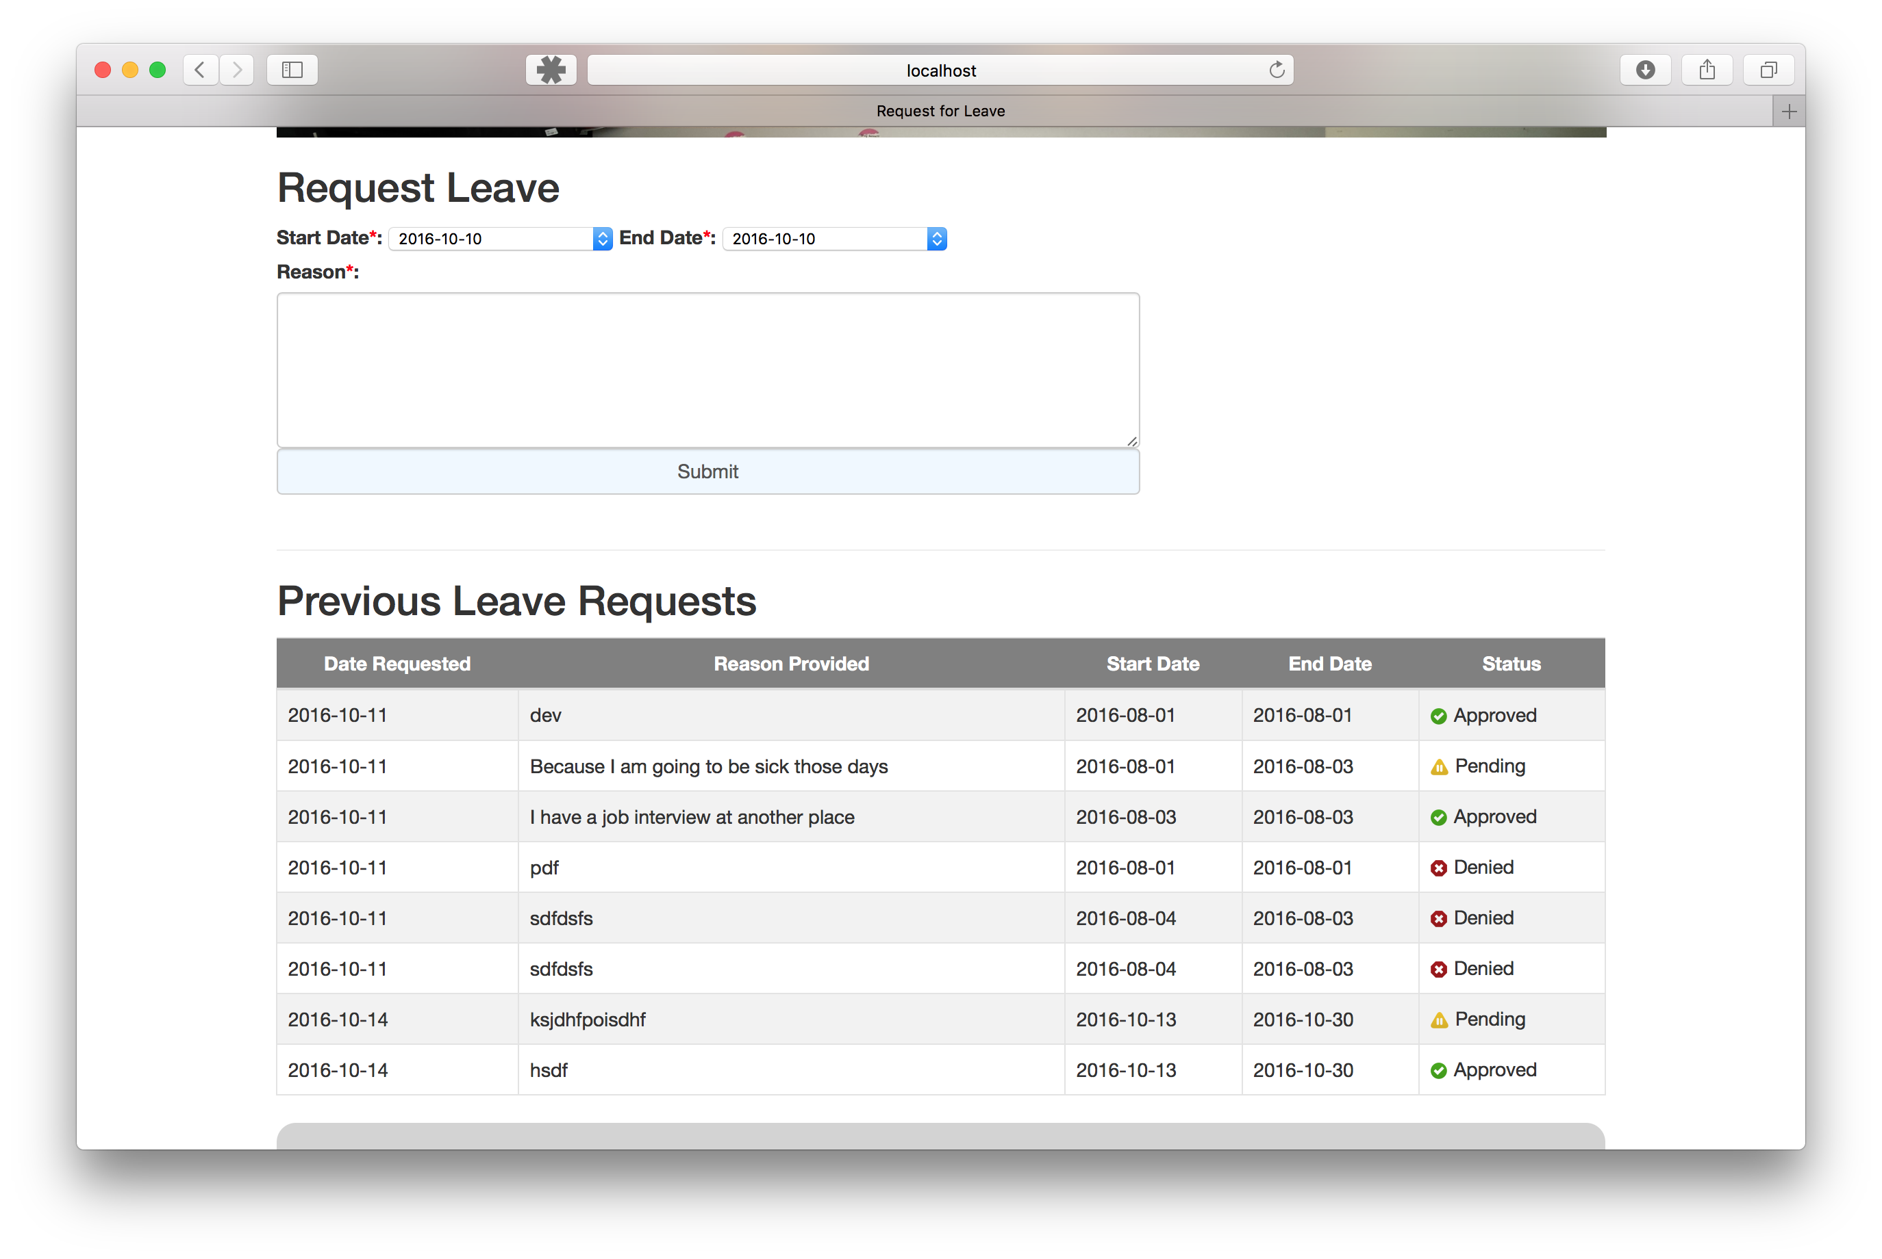

### Leave Request Page

Location: pages/leave/requestLeave.php

The Leave Request page is accessible by students or teachers and features a form for creating a leave request and a list that shows all the previous requests they have made and the status of the request. The form sends the details to a processing page to added the request to the database and then that student or teacher will see that request on the Previous Leave Requests table.

The Previous Leave Request table can be sorted alphabetically for each column, allowing the user to group the requests by status, or by start date etc. This was achieved with JavaScript and jQuery and has been reused throughout the site for various other tables with data I believed was worth sorting.

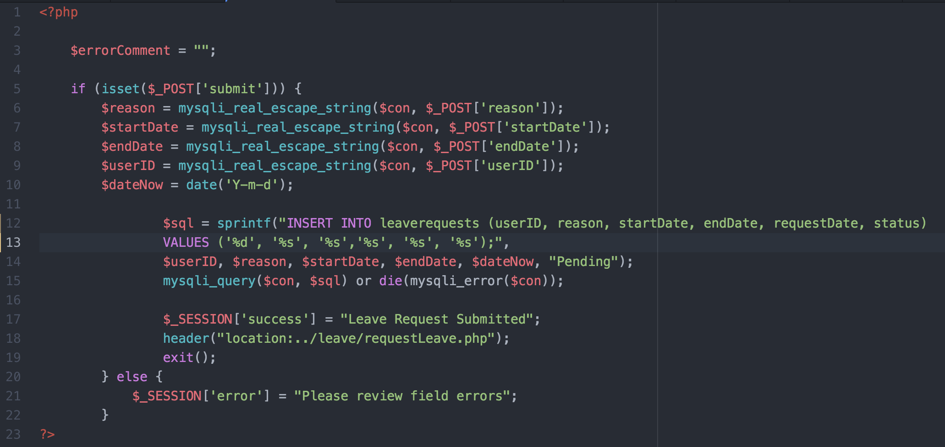

### Leave Request Processing

Location: inc/leaverequestprocessing.php

When a request is submitted on the Leave Request page it is processed by this include. It inserts into the database the input data from the user as well as the date that the request was made ($dateNow) and a fixed value of “Pending” for the status.

**Manage Leave Request**

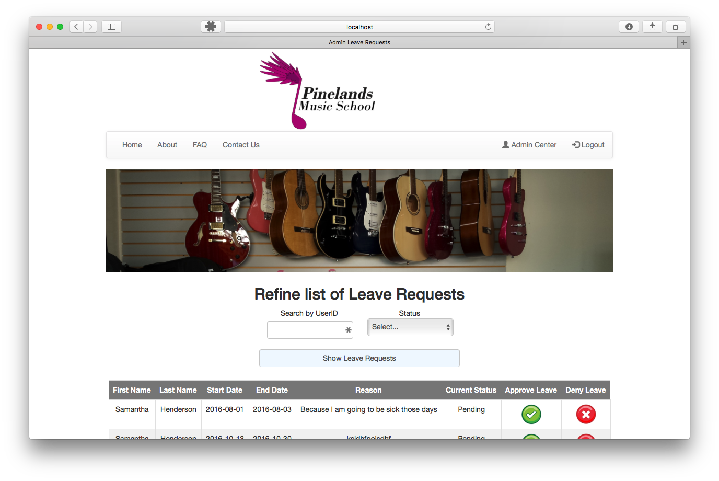

### Review Leave Requests

Location: page/leave/reviewLeaveRequests.php

The next task I looked at was making it possible for the admins or owner to review the requests. This page was also intended to provide them with the power to change the status to Approve or Deny any requests.

The solution to this problem was created two because the initial solution required several clicks to change the status. The team and I agreed that a solution similar to the Instrument Hire would be more consistent and provide a better solution to the end user.

In the final solution the page is comprised of a search and a list of results. By default, it only shows the Pending requests so the admin can see what they have to action straight away. This list can however be extended or refined with the search.

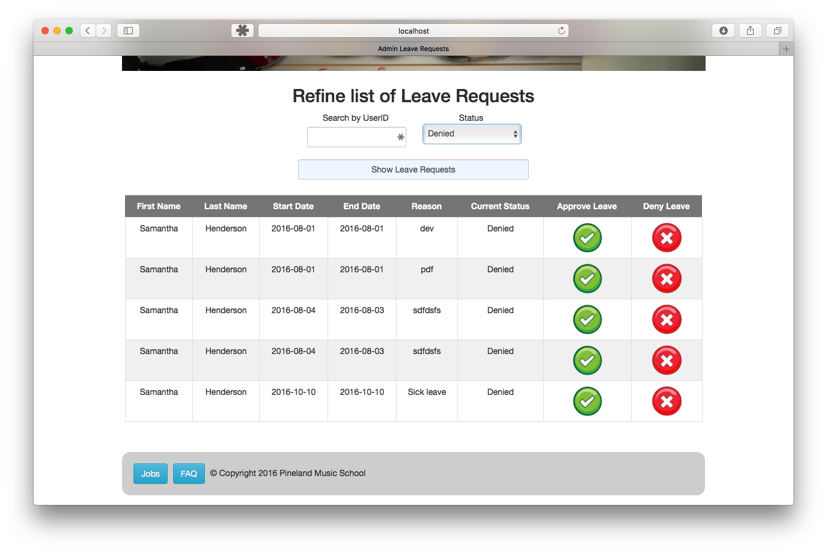

By changing the status to Denied, the list shows only request that have been denied.

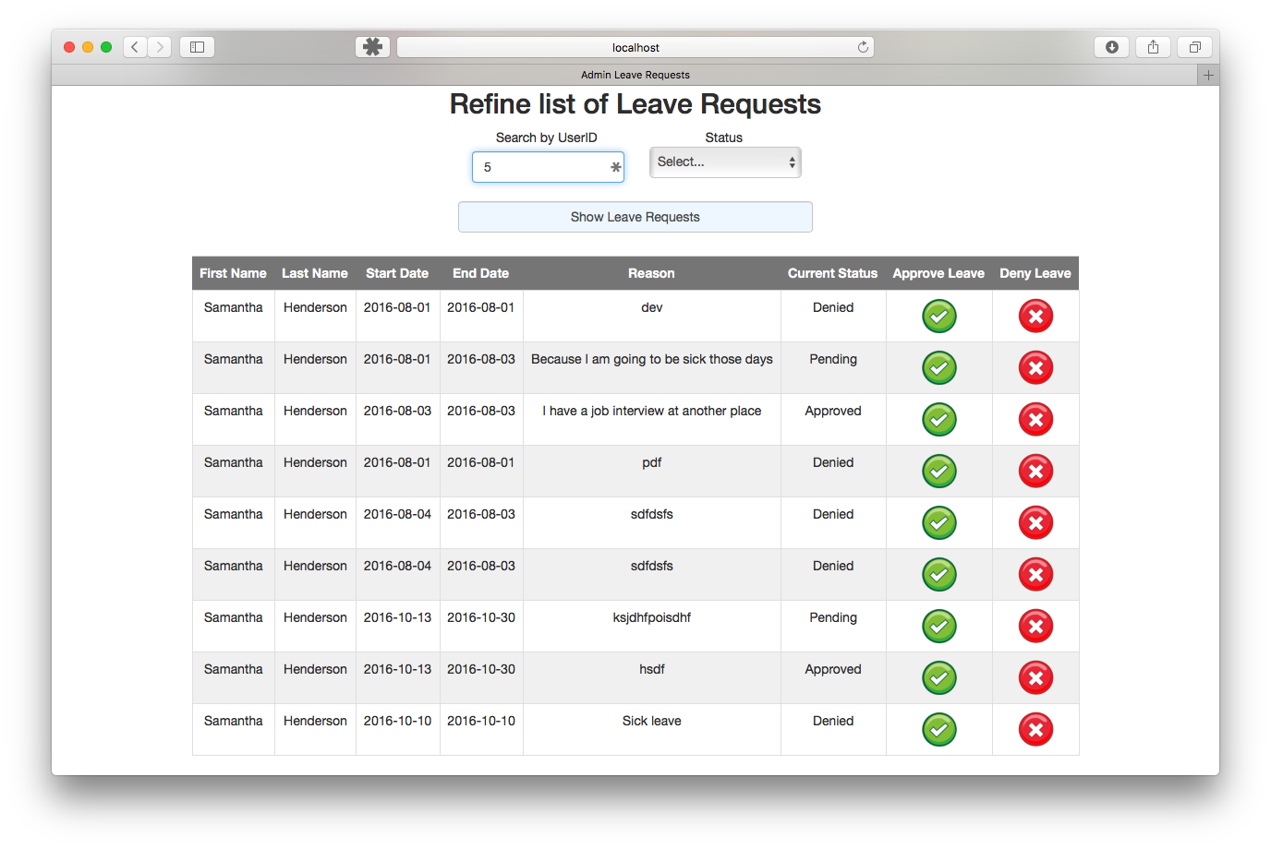

By searching for a userID, the list is refined to only request from the specified user.

By clicking the Approve Leave tick or the Deny Leave cross the admin or owner can change the status of the request in one click.

**Manage Reviews**

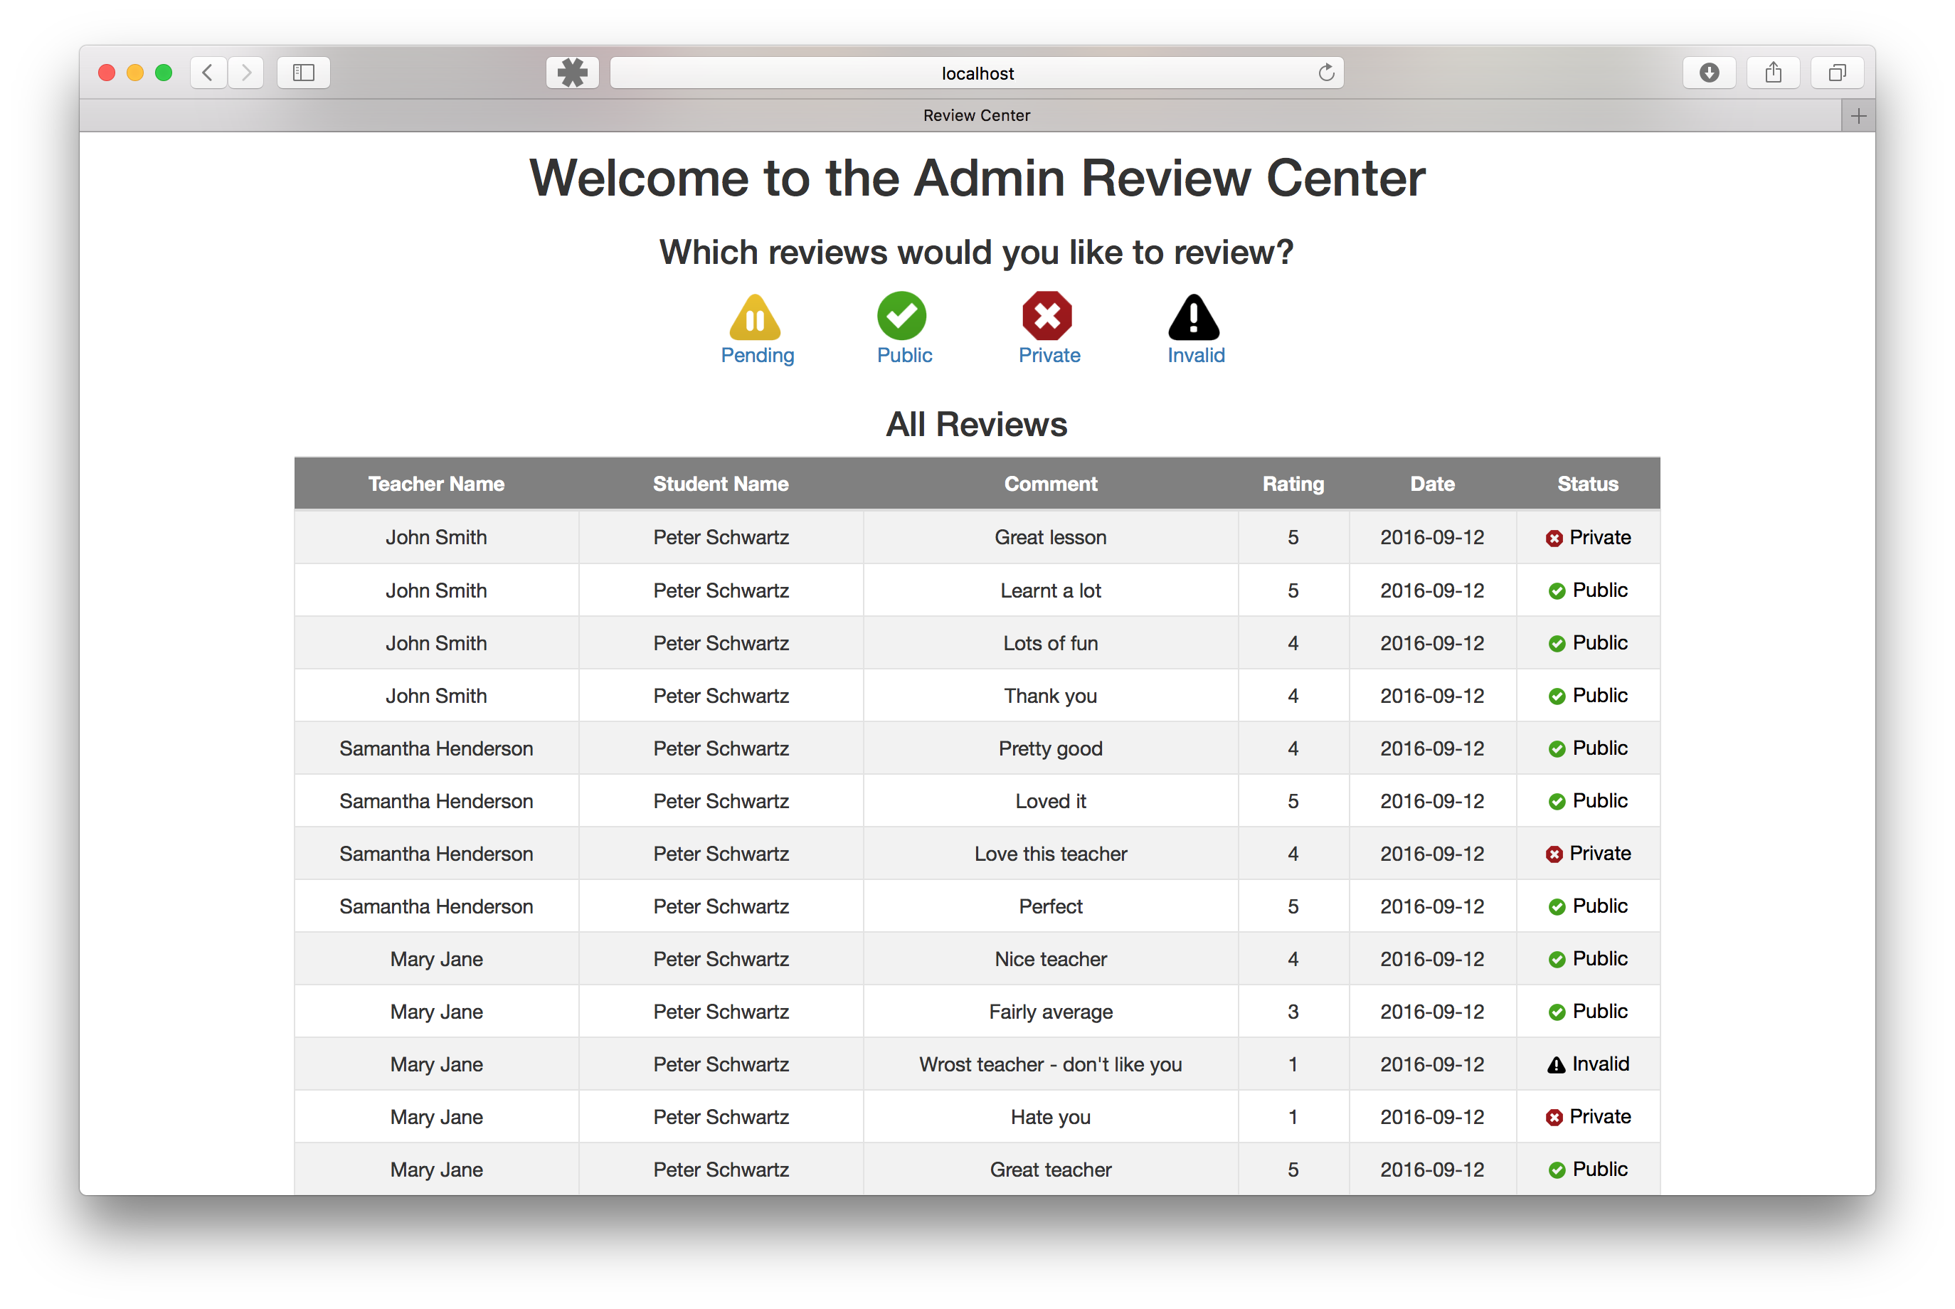

### Manage Reviews Page

Location: page/admin/adminReviewCenter.php

This page was developed to allow admins and owners to view reviews about the teaching staff by students. Each review can be assigned a different status to change how that review is used throughout the website.   
For example, on the Our Teachers page, only reviews with the status public with modify the star rating. On Testimonials only public reviews will be shown about teachers etc.

This functionality was built to allow admins to monitor the happiness of the students and the performance of the teaching staff as well as creating content to show potential students or teachers what to expect from the school.

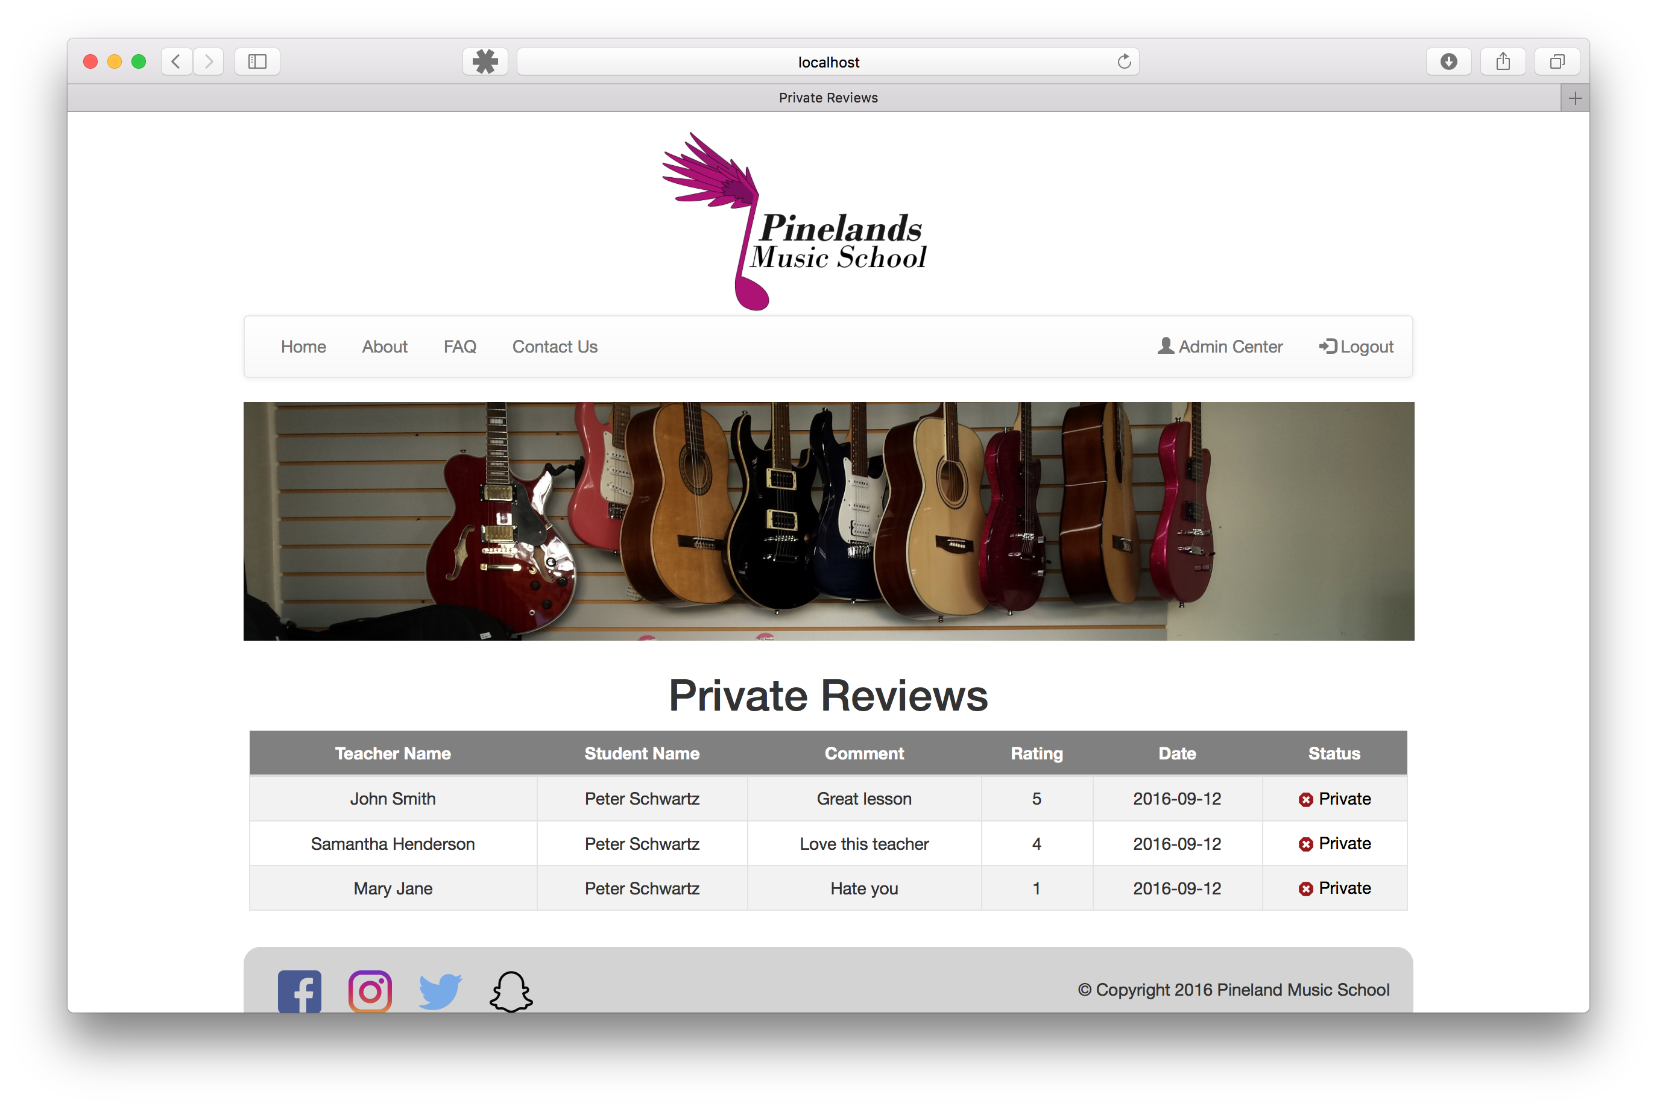

The page also has some sorting features so you can modify the list to see only what is important at the time. This includes being able to see only reviews of a particular status or sorting by columns in the tables.

**Review Teachers**

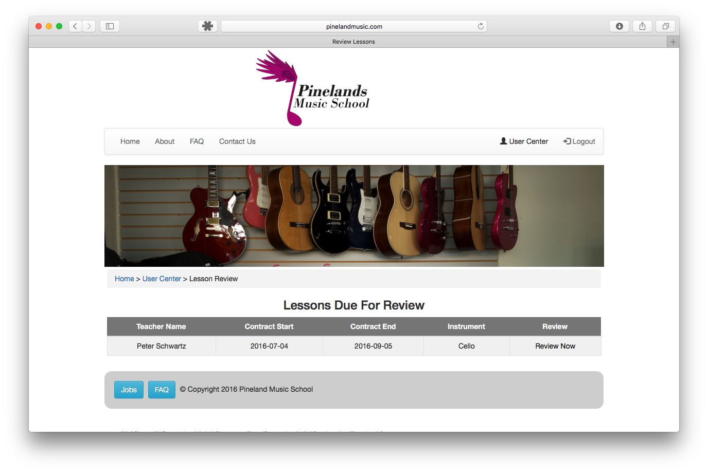

### Review Teachers Page

Location: page/teacherReview/reviewLessons.php

This page displays students a list of contracts that have ended that need to be reviewed so the admins, owner and teacher can see what they are doing right and wrong. Each Contract due for review includes the teacher’s name, the start and end date and the instrument the lesson was for.

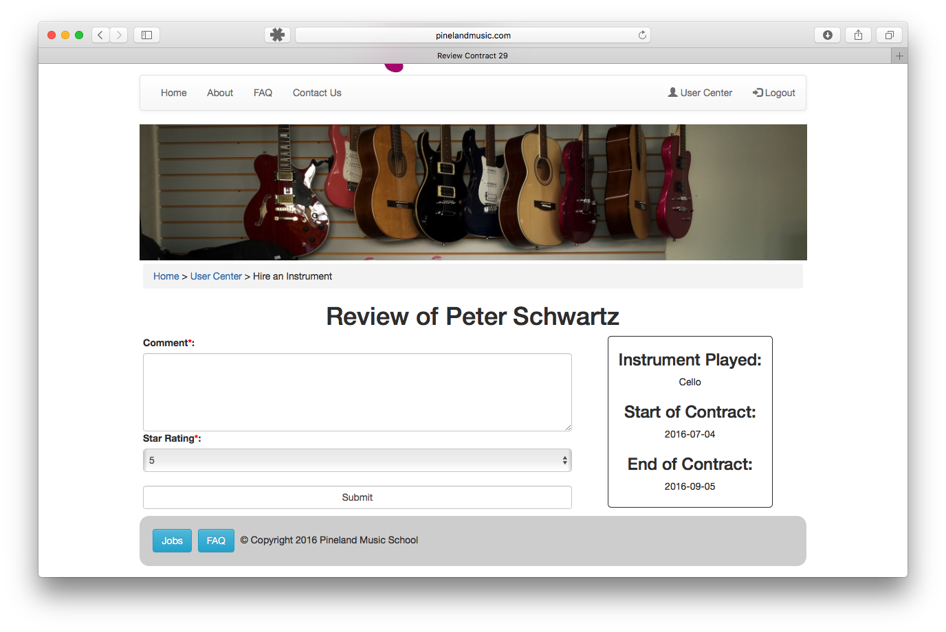

### Write Review Page

Location: page/teacherReview/writeReview.php

When the user selects the contract and teacher they want to review that are taken to a page that has a form that they need to complete. They are asked for a star rating and to leave a comment. On the right of the form there is a reminder of the information about the contract so they know the period that contract is in, the teacher’s name and what instrument they learnt in that contract.

When submitted it is added to the database and can be viewed by admins or owners.

**Testimonial Pages**

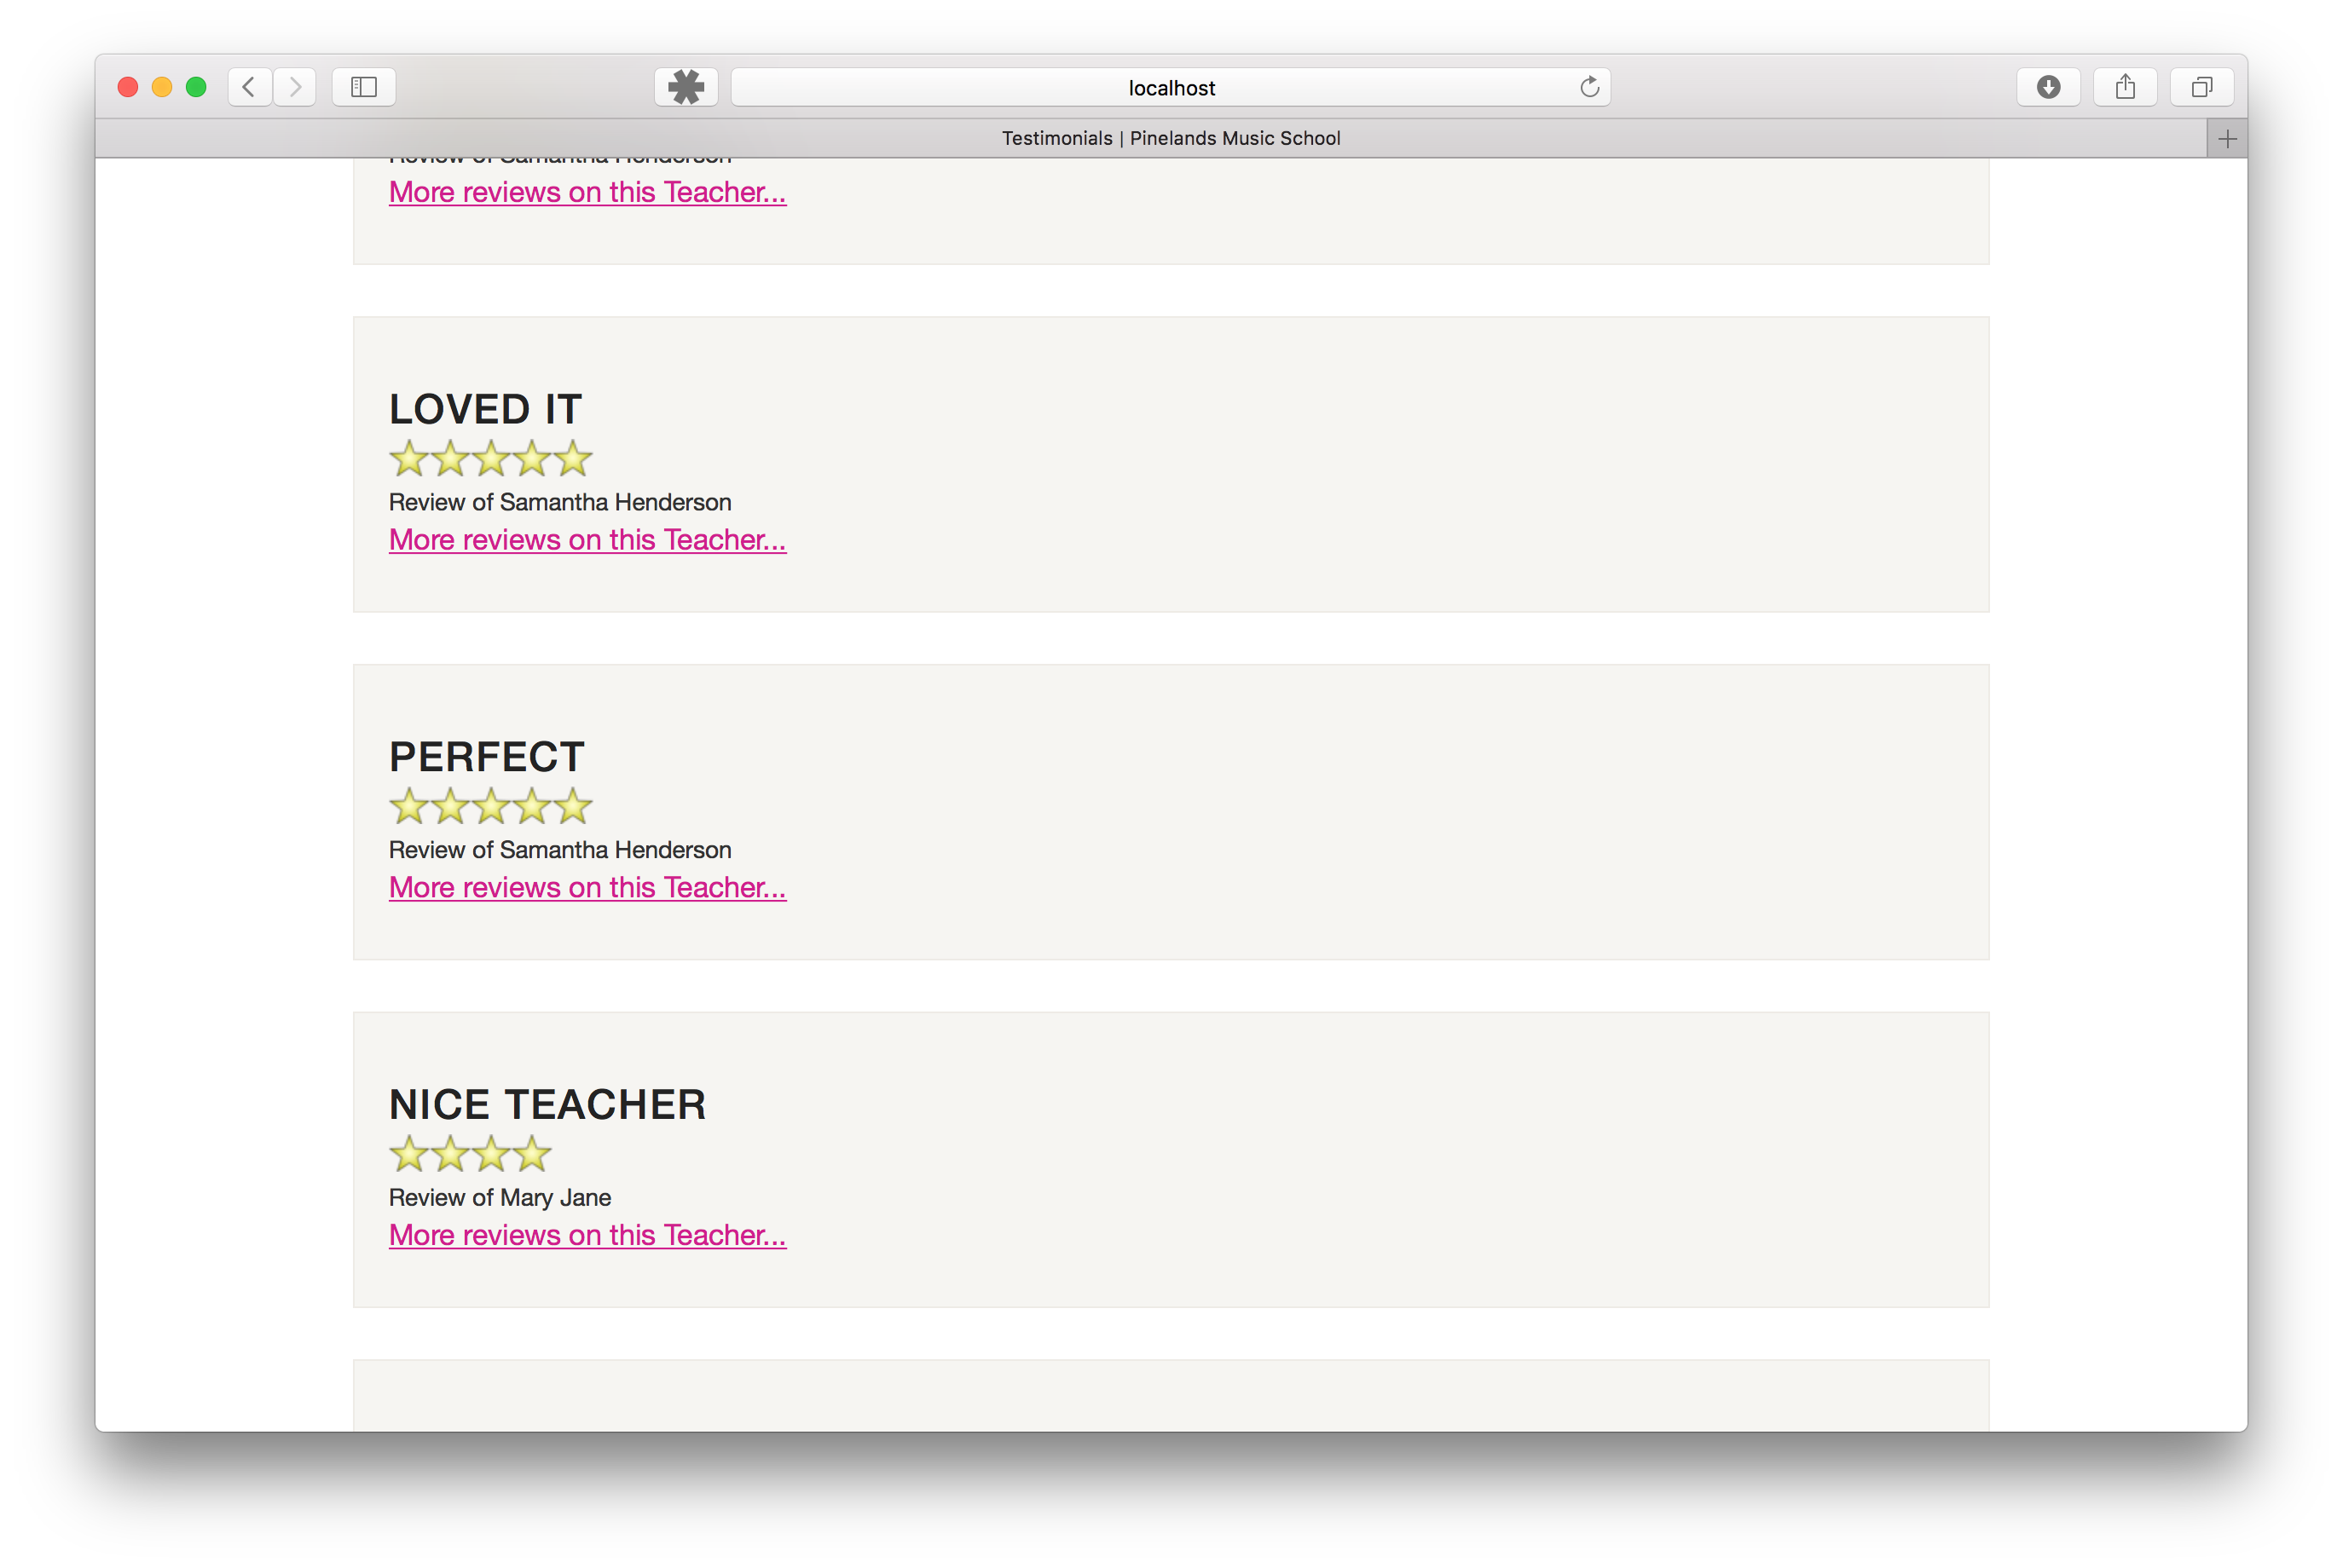

### Testimonials Page

Location: page/testimonials/testimonials.php

Developed to improve the completeness of the website, these pages are informative and draw data, supplied but the students from the database. The testimonials page displays all the reviews with a public status. They show the comment made by the student, a star rating and the teachers name but for privacy reasons does not show the name of the student.

Each testimonial on this page also includes a link to show only reviews about a particular teacher. This allows a potential student research each teacher before selecting a teacher to teach them.

